DRAFT - IT Project Guidance

Long Lifespan System Design Considerations

Version:

0.7

## Description

This document outlines a aspects to consider when designing and selecting services intended to have long service durations.

## Synopsis

The nature of government bidding and funding, and larger cost of nationally deployments of services by government agencies, combined with an inability to be renumerated, implies the service will require a long service span to fully depreciate its investment.   
This long duration impacts service design and procurement decisions.

## Contents

Description 1

Synopsis 1

Contents 2

Introduction 3

Design for The Users’ Future 3

Consider developing multiple Service Interfaces 4

Appendices 6

Appendix A - Document Information 6

Versions 6

Images 6

Tables 6

References 6

Review Distribution 6

Audience 6

Structure 6

Diagrams 7

Terms 7

## Introduction

The slow cadence and outcome uncertainty of government bids and funding, services are expected to have a relatively long service lifespan before funding is again available.

If anything, the higher cost of government led projects for deploying nationally available services -- combined with the practice of not charging renumeration for government services – only elongates the service lifespan required to depreciate the investment made in it before committing to investing in its replacement.

Secondly, the planning, design, development, piloting and deployment of nationally available services takes a tremendous amount of up front time, which pushes out the date from which the service will be first available to end users.

The pushing out of the start date, combined with long service lifespan impacts on design requirements.

# Considerations

Consider managing the following considerations when developing services intended for long service.

## Consider Designing for The Users’ Future

Whereas faxes are no longer with us, touch-screen mobile cell phones, multiple communication channels other than email[1], Siri, Chat-GTP, DALL-E, electric skateboards, scooters, and vehicles, along with solar panels and gigantic wind turbines, self-checkout store facilities, and factory robots are all common sights -- to varying degrees[2] -- to learners today.

Developing software and information for consumers today that doesn’t refer to and incorporate this already existing conditions condemns the product to being non-current from the start, with less chance of remaining current.

If progress continues at a similar pace -- and there is no indication of it slowing down -- the future during which learners will be using any long-term service designed today will be replete with technologies that already exist, and more. Examples of current technology include AI, surveillance[3], warehouse and consumer store stocking, restaurant cooking galley[4] and dining room service robots[5], self-guiding road delivery[6], aerial drone goods delivery[7], AI assisted motorcycles[8] -- even care robots at the nursing homes of their relatives[9][10].

In such a context, a desktop-based assessment service expected to be viewed on 21” flat screens, with little to no consideration of mobile display, single-hand swiping motions, optional voice control, images hand-drawn 20 years earlier, etc. does not project the authority of currency to the intended user base.

Important:  
Stakeholders must put in the effort to become comfortable with accepting predicted technical *trends*, rather than sticking with the comfort of what is current, and backable by *evidence*.

## Consider User Type Specific Interfaces

While a learner’s future will have more technology than today, one can’t expect a learner’s teacher, who may be one to four decades older, to have the same digital fluency as a learner.

Consider the intended user base carefully, separately, and avoid considering them as a homogenous group too early.

For example, pedagogical services are used by both learners and teachers – but their characteristics and needs are distinct in terms of functionality, screen layout, devices used, etc.

Learners are younger and generally far more tech-savvy, requiring far less instruction and assistance to use systems than their teachers, who may be older, but also have more responsibilities to manage limiting their time to learn new technologies.

Consider whether the distinct needs are best met as common modules within a single interface or require distinct interfaces altogether.

|  |  |
| --- | --- |
| Figure 1: Separate Presentation Modules | Figure 2: Separate Presentation Interfaces |

Having a common presentation platform, with distinct modules, permits sharing of common logic, as well as appearance, but having separate interfaces tailored to the target audience permits addressing other opportunities.

Essentially, using a different interface for a tech-savvy user base permits developing for them, while using a different interface more appropriate for a other users.

Tech savvy users may have different devices, different input and output preferences, and use the service from different locations.

Whenever they have one and are permitted to use them, Learners use their own devices to access services. This implies the service should be available on much smaller mobile cell phone screens, focusing more on a very small set of action choices, by removing distracting and screen real-estate consuming buttons and links. Whereas for teachers, the service is a work tool, that may require a larger screen to better display and offer a wider set of controls and options.

Learners use the service, and expect reports about themselves to be quickly accessible, but not printed. Teachers instead require reports about whole cohorts, while being able to drill into a single student’s results. Additionally, they may need a single learner’s result, but in a different way than a Learner may have needed. For example, the report may be used to discuss outcomes with the Learner’s outcome.

## Consider Improving Support and Operations Capabilities

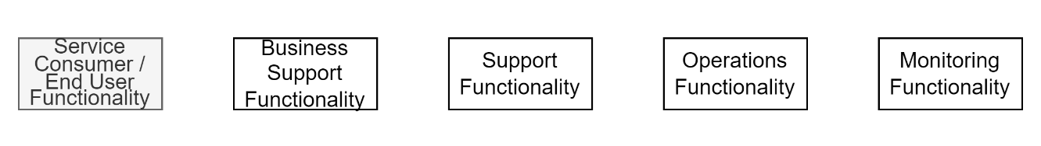

Figure 3: Non-Consumer Capabilities & Functionality

The cost of fielding calls to reset user logins, where to find a specific feature, or explain why it wasn’t added is potentially absorbable for a short while. However, these sum cost of these trivial operations add up to a large cost over a long service lifespan.

Consider ensuring that functionality is in place to

* Improving the way users can accept versioned Terms & Conditions in order to be come and remain a User
* Improving access and security by permitting users to reset their password in a secure manner,
* Improving learnability by avoiding physical deletion of records, such that users can undo their last operation.
* and Improving usability by automating and streamlining the way users can apply to be invited to a role that provides more permissions,
* Improve navigability by providing navigation of functions by both nested navigation bars (the traditional approach used by desktop apps), as well as text search,
* Providing notification of planned system changes in the system, as well as the status and resolution of unplanned outages,
* Etc.

## Consider using an automated deployment approach

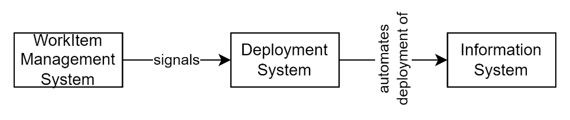

Figure 4: Delivery Automation

The cost of deploying a couple of times by hand is arguably hard to justify automation thereof – but deployments 26 times (every fortnight) a year, for 10 years, it’s impossible to justify avoiding it.

# Conclusion

Services that are to be run for a long time do not add any *new* requirements for functionality and capability that should be in an system -- but do make it to justify deferring their inclusion.

Appendices

Appendix A - Document Information

### Author & Contributors

Sky Sigal, Solution Architect

### Versions

* 1. Initial discussions about user base.

0.4 Added discussions about interfaces.

0.7 Added consideration of capabilities and deployment.

### Images

Figure 1: Separate Presentation Modules 5

Figure 2: Separate Presentation Interfaces 5

Figure 3: Non-Consumer Capabilities & Functionality 6

Figure 4: Delivery Automation 7

Tables

**No table of figures entries found.**

### References

**There are no sources in the current document.**

### Review Distribution

The document was distributed for review as below:

|  |  |
| --- | --- |
| Identity | Notes |
| Sandy Britain, Enterprise Architect |  |
| Amy Orr, Data Domain Architect |  |
| Rodney Sneer, Technical & Business Lead |  |

### Audience

The document is technical in nature, but parts are expected to be read and/or validated by a non-technical audience.

### Structure

Where possible, the document structure is guided by either ISO-* standards or best practice.

### Diagrams

Diagrams are developed for a wide audience. Unless specifically for a technical audience, where the use of industry standard diagram types (ArchiMate, UML, C4), is appropriate, diagrams are developed as simple “box & line” monochrome diagrams.

### Terms

Refer to the project’s Glossary.

##### IT

: acronym for Information, using Technology to automate and facilitate its management.

##### ICT

: acronym for Information & Communication Technology, the domain of defining Information elements and using technology to automate their communication between entities. IT is a subset of ICT.

##### UI:

acronym for [Graphical] User Interface

##### Tier

: software is developed as Layers (Presentation, Logic, Infrastructure) deployed to one or more physical Tiers hosted on distinct Devices.

1. Facebook, Instagram, Snapchat, WhatsApp, Telegram, Neighbourly, Messenger, etc.
2. Admittedly more prevalent in urban versus rural settings.
3. [Is that streetlight watching you – and eavesdropping too? - The Conservative Woman](https://www.conservativewoman.co.uk/is-that-streetlight-watching-you-and-eavesdropping-too/)
4. [Fast food chain to replace humans with robotic fry cook | ZDNET](https://www.zdnet.com/article/fast-food-chain-to-replace-human-robotic-fry-cook/)
5. [Where you can find Robots serving customers in NZ - Robots for Restaurants (grobotics.co.nz)](https://grobotics.co.nz/where-you-can-find-robots-serving-customers-in-nz/)
6. [Serve Robotics to deploy up to 2,000 sidewalk delivery bots on Uber Eats | TechCrunch](https://techcrunch.com/2023/05/30/serve-robotics-to-deploy-up-to-2000-sidewalk-delivery-bots-on-uber-eats/)
7. [Amazon, UPS, Domino's & the Future of Drone Delivery Services (insiderintelligence.com)](https://www.insiderintelligence.com/insights/drone-delivery-services/)
8. [Yamaha presents bizarre, twisting, self-balancing Motoroid 2 (newatlas.com)](https://newatlas.com/motorcycles/yamaha-motoroid-2/)
9. [Robots being used in aged care settings | Australian Seniors](https://www.seniors.com.au/life-insurance/discover/robots-aged-care)
10. Again, each being first seen in urban settings first, making its way to rural environments relatively quickly.